**African Travel, Inc. Launches Travel Advisor Incentive to Win a $30,000 Safari Adventure of a Lifetime**

*Opportunity to win the ultimate Kenya and Tanzania luxury journey for every booking made my April 30, 2025*

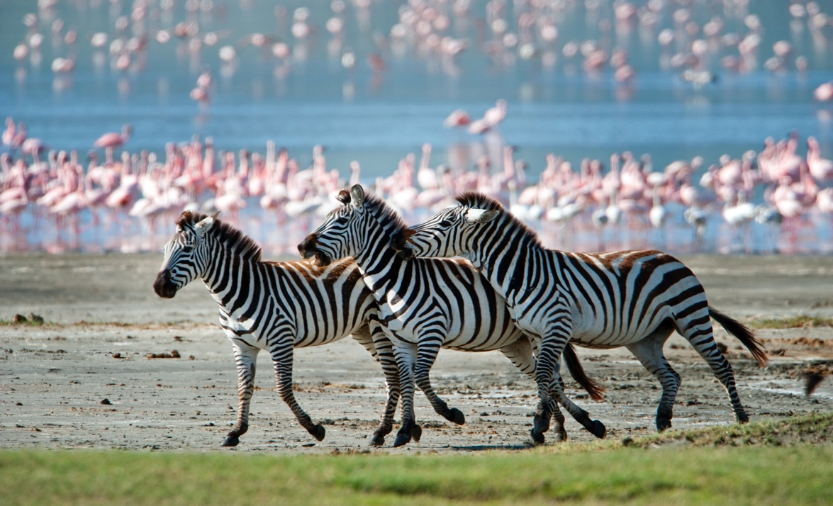

*\*Insert Approved Press Release Image*

**Glendale, CA** **– January** **14, 2025 –**[**African Travel, Inc. (ATI)**](https://africantravelinc.com/)**, the award-winning luxury safari outfitter is excited to announce that Travel Advisors have an opportunity to turn their bookings into winning an adventure of a lifetime on the** [***World’s Greatest Show & Safari***](https://africantravelinc.com/safari/worlds-greatest-show-serengeti)**itinerary. For every booking made by April 30, 2025, advisors will earn a chance to** [**win a $30,000 USD luxury safari**](https://africantravelinc.com/content/win) **to Kenya and Tanzania for themselves and their chosen guest.* The more they book, the greater chances of winning this unforgettable journey, including exploring renowned wildlife reserves, stays at stylish Elewana camps, all meals, and round-trip international airfare from JFK airport to Nairobi.**

**As another benefit to our advisor partners, ATI is offering, a $300 digital gift card incentive for every couple booked on their brand new** [**Concierge Safaris**](https://africantravelinc.com/content/concierge-safaris) **before March 31, 2025.\*\***

“We are thrilled to kick off the New Year by offering our valued Travel Advisors, the opportunity to win the ultimate East Africa safari with a traveling companion including international flights," **says Sherwin Banda, President of African Travel, Inc.** "Our Advisor community will enjoy a friendly competition with our incentives by selling our range of safari styles to engage their clients, from guided group adventures to bespoke journeys, to fully escorted vacations, there’s something for every traveler," **he adds.**

The 11-night [***World’s Greatest Show & Safar****i*](https://africantravelinc.com/safari/worlds-greatest-show-serengeti)itinerary showcases the very best of Kenya and Tanzania and the incredible opportunity to observe the Great Migration of millions of wildebeest and zebra across East African’s vast plains. Clients will explore the Ngorongoro Crater, regarded as one of the Natural Wonders of the World and the exhilarating thrill of tracking Africa’s Big Five to witness the annual migration during the crossing. They will enjoy expertly guided morning and afternoon game drives at Serengeti National Park.

**For more information please visit:** [**https://africantravelinc.com/content/win**](https://africantravelinc.com/content/win) **or contact your local Sales Manager.**

Follow African Travel, Inc. on [Facebook](http://www.facebook.com/AfricanTravelInc/), [Twitter](http://twitter.com/_AfricanTravel_) and [Instagram](http://www.instagram.com/africantravelinc), and join the conversation using the hashtag #WeKnowAfrica.

**-Ends-**

**\*Terms and Conditions:**

* This promotion is open to travel agents who book eligible packages through African Travel, Inc. between January 14, 2025, and April 30, 2025. Each deposited booking earns one entry into the drawing to win a prize. The prize includes a trip to Kenya for the winning agent and one companion, based on double occupancy, including international airfare from JFK on Kenya Airways. Fuel surcharges, government taxes, departure taxes, and September 11th Security Fees are included. The prize itinerary is predetermined and cannot be altered. Travel dates must fall between October 1, 2025, and March 31, 2026, excluding Christmas, New Year’s, and Easter holidays, and are subject to availability. The prize is non-transferable and cannot be redeemed for cash or substituted for other goods or services. Winners are responsible for any applicable personal taxes and must complete and submit an IRS Form W-9 prior to receiving the prize. A Form 1099 will be issued for the estimated value of the prize, which must be reported as income. The winner will be notified by email or phone by April 10, 2025. Failure to respond within seven (7) days may result in forfeiture of the prize, and an alternate winner may be selected. Additional restrictions may apply. For full details, please visit https://africantravelinc.com/about/terms-and-conditions.

**Offer applies to new bookings of the Escorted Vacations only.  A non-refundable deposit must be made between December 1, 2024 and March 31, 2025 for bookings traveling in 2025. The incentive is based on $150 per traveler and is provided as a digital gift card issued in the name of the travel advisor, the month following the deposit. Not combinable with other incentives, member benefit savings or promotions. Subject to change without notice; not retroactive or transferable. Other restrictions apply. CST#2071444-20

**ABOUT AFRICAN TRAVEL, INC. - *"WE KNOW AFRICA"***

[**African Travel, Inc**](https://africantravelinc.com/)**.** is the longest-established luxury safari operator based in the US, focused exclusively on the African continent. With staff across North America and Africa, we create tailor-made safaris. Through our [#MakeTravelMatter](https://africantravelinc.com/about/african-travel-cares) program and partnership with [The TreadRight Foundation](https://africantravelinc.com/about/treadright-foundation), we are committed to helping the people, wildlife and the planet. Each safari supports a child’s education or wildlife conservation project. African Travel is an award-winning luxury safari company and a proud member of [The Travel Corporation](https://africantravelinc.com/about/travel-corporation) (TTC), committed to its signature ‘Driven by Service’ philosophy and to consistently delivering outstanding experiences and value to travelers, guests, and partners.

**Media Contact:**

**Marie Anne MacRae |** Global VP, Strategic Partnerships | The Travel Corporation | **E** [marieanne.macrae@ttc.com](mailto:marieanne.macrae@ttc.com)

**Shreya Pardeshi** | PR Coordinator | The Travel Corporation| E[shreya.pardeshi@ttc.com](mailto:shreya.pardeshi@ttc.com)