**How To Find “The Hub” From Your Browser**

**ADD**

<http://TheHub.cluballiance.aaa.com>

**To Your Bookmarks**

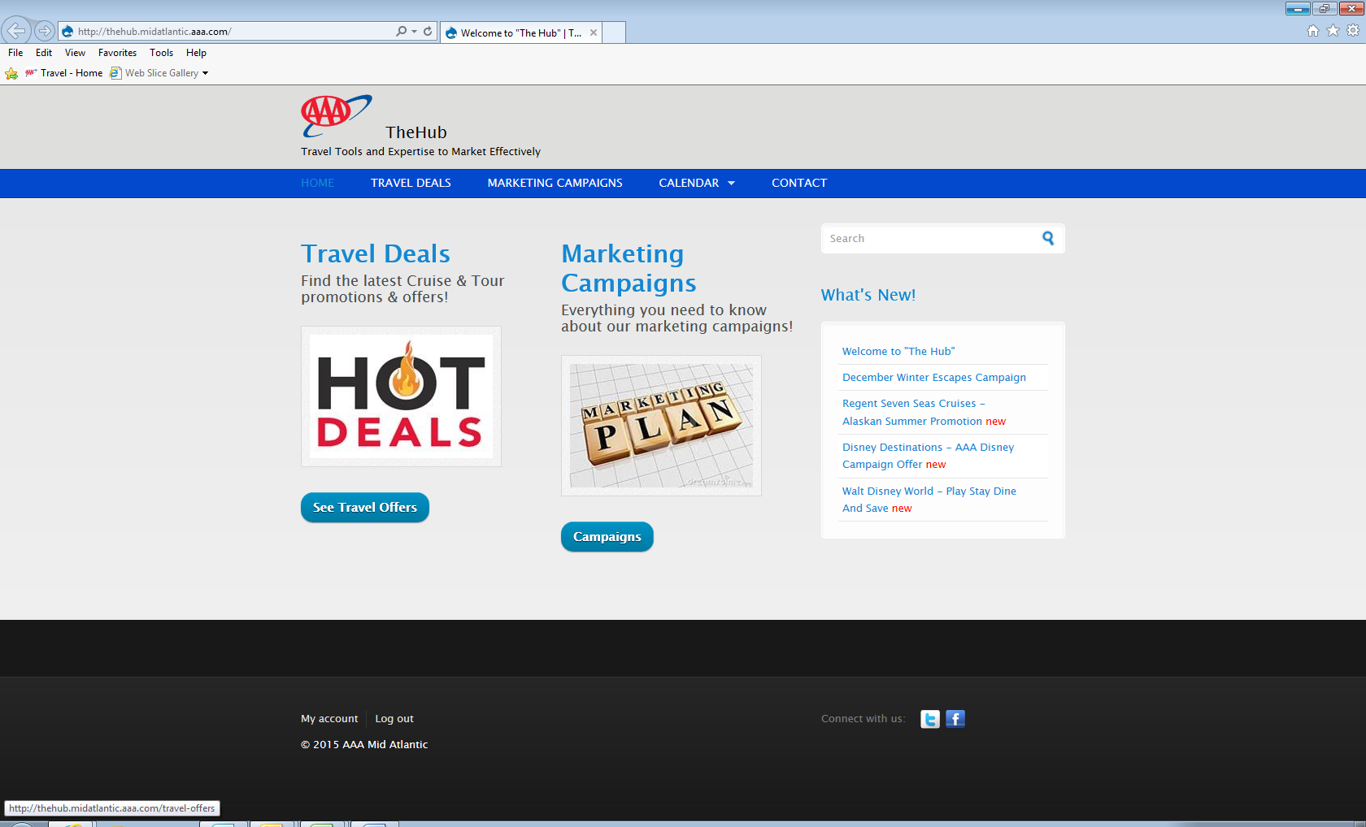

**How To Find A Supplier Offer**

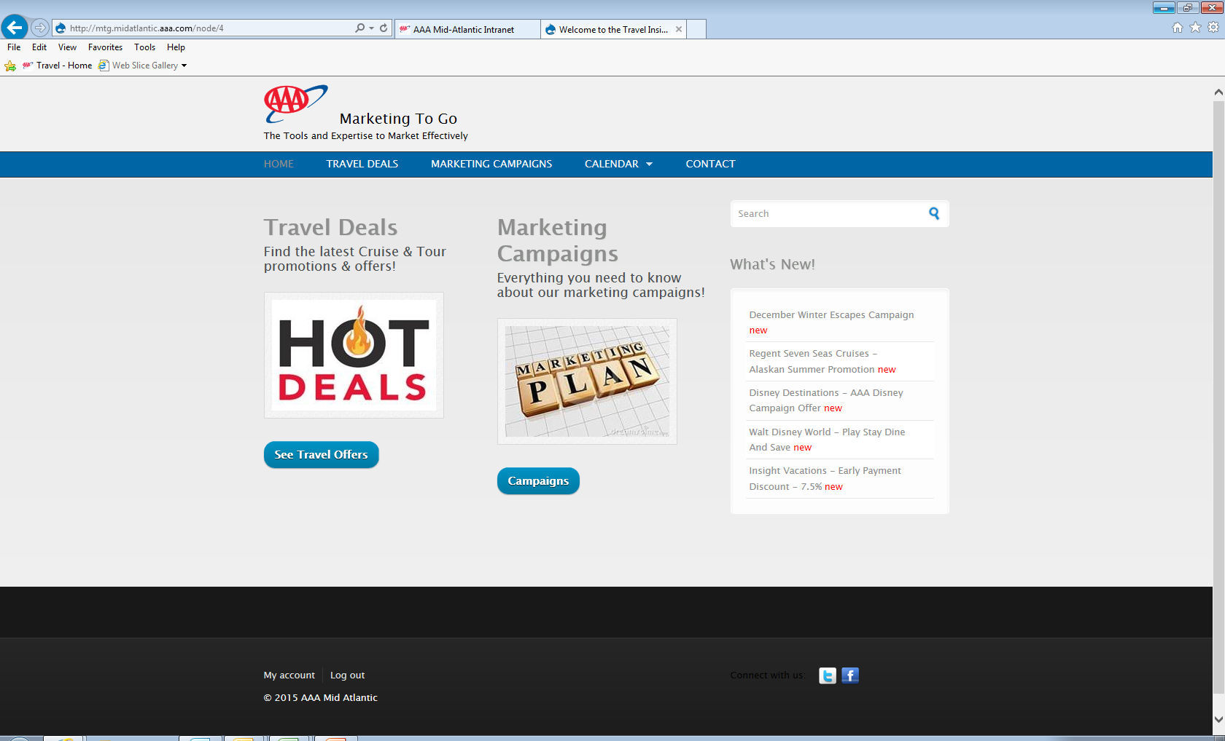

**Click any of these for latest Travel Deals**

**How to sort through all Deals**

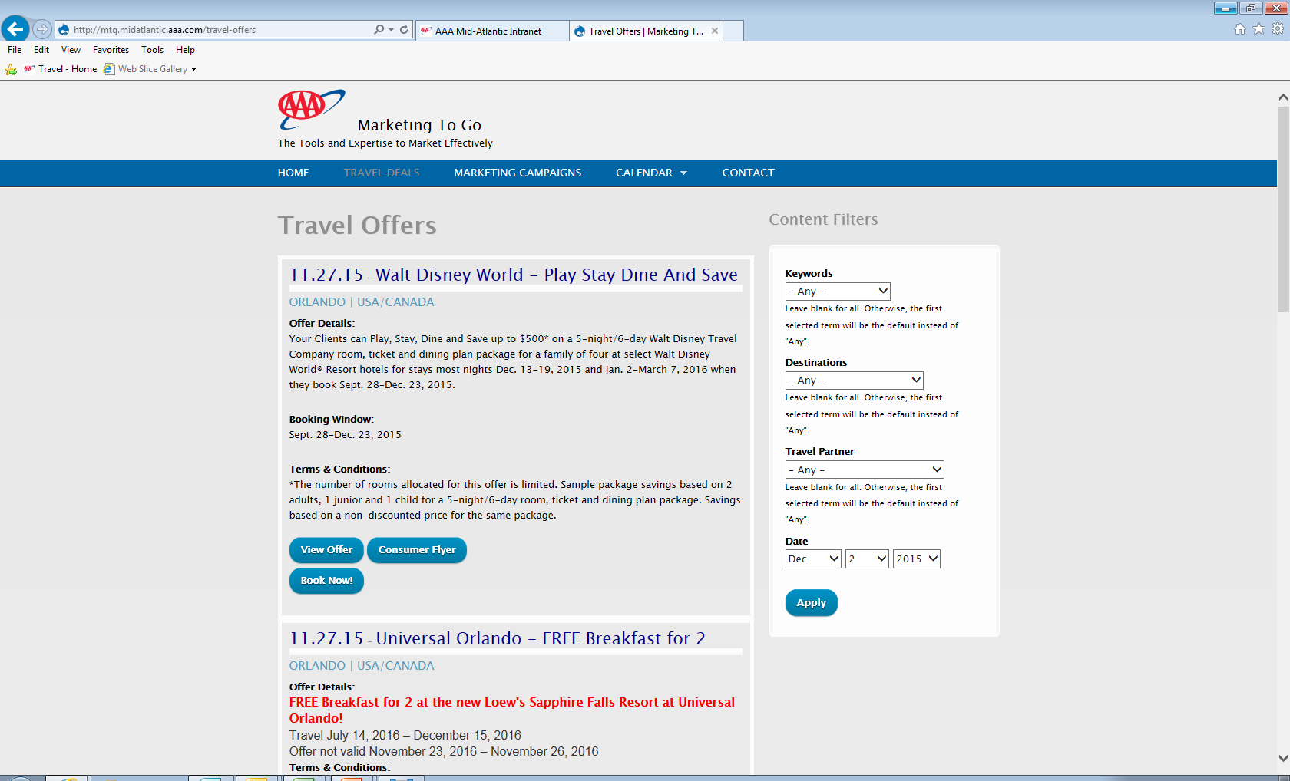

**Use these filters to sort by…**

* **Type of Travel**
* **Destination**
* **Partner**

**How To Get The Details Of The Offer**

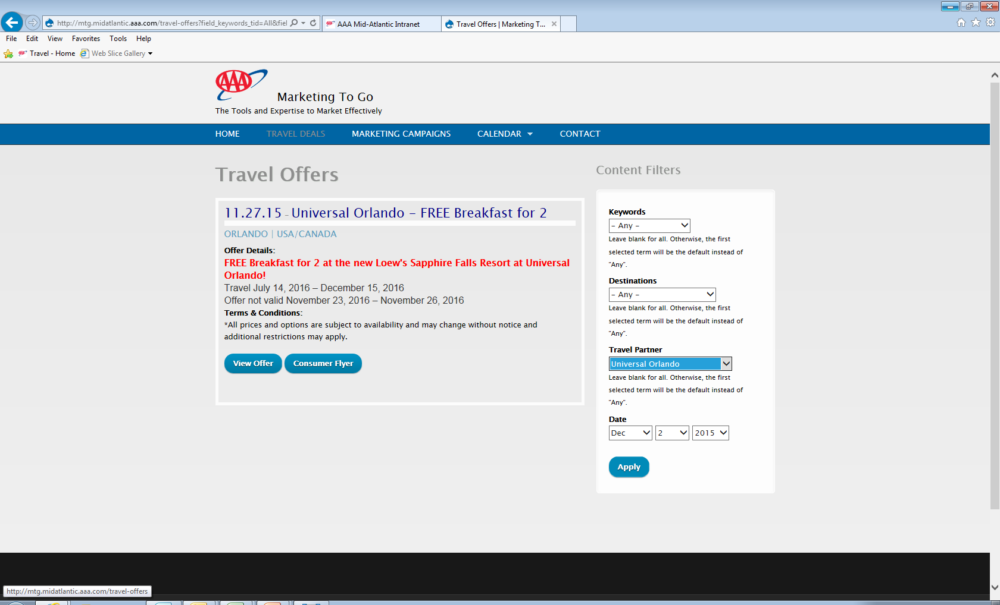

**Click here to see details of a Deal or Offer**

**How to use the Calendar to find a Deal**

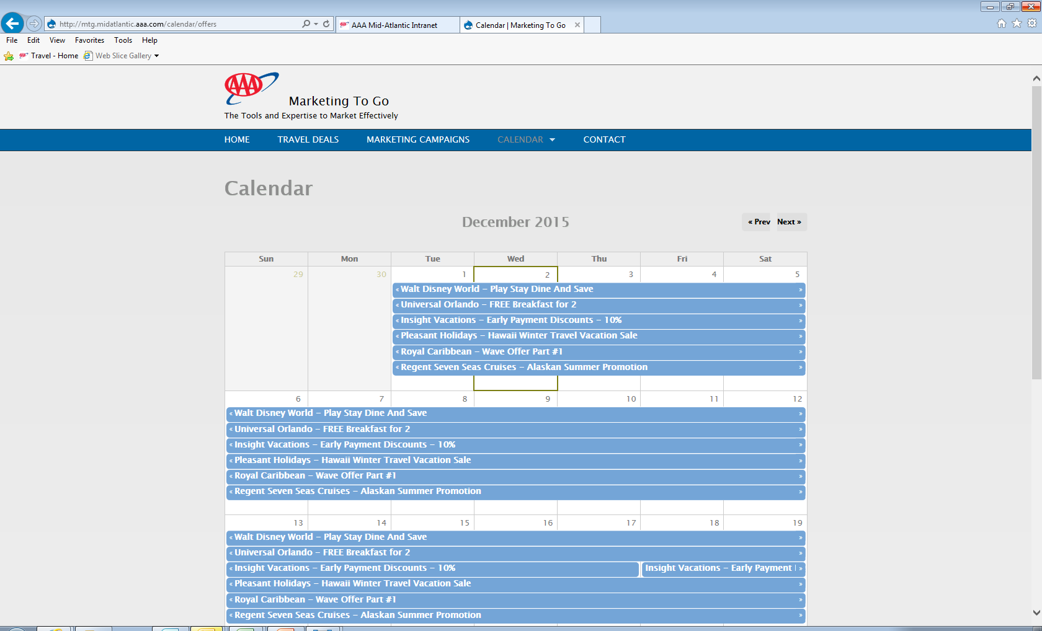

**Click on any of the line items on today’s date to see available deals today!**

**How To Find Which Marketing Campaigns Are In The Marketplace Today**



**Click on one of these…**

**How To Get The Details Of The Campaign**

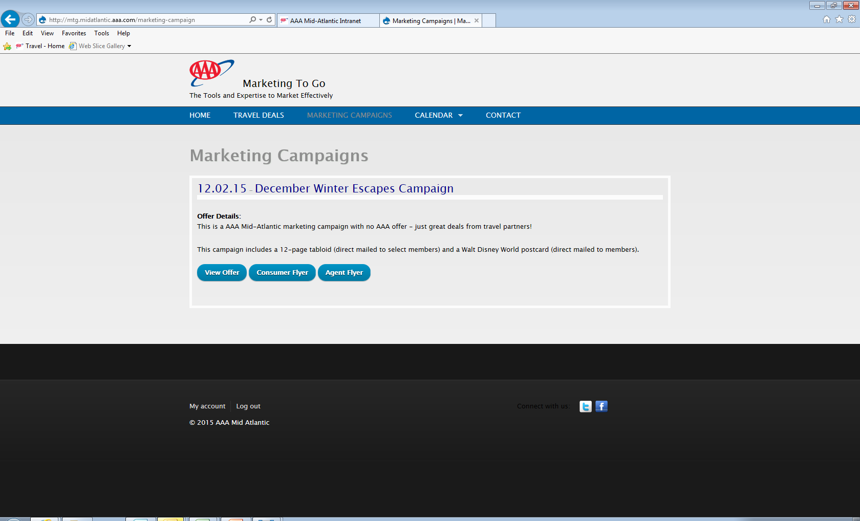

**Click on these to get details of a marketing campaign…**

**How to use the Calendar to find Marketing Campaigns**

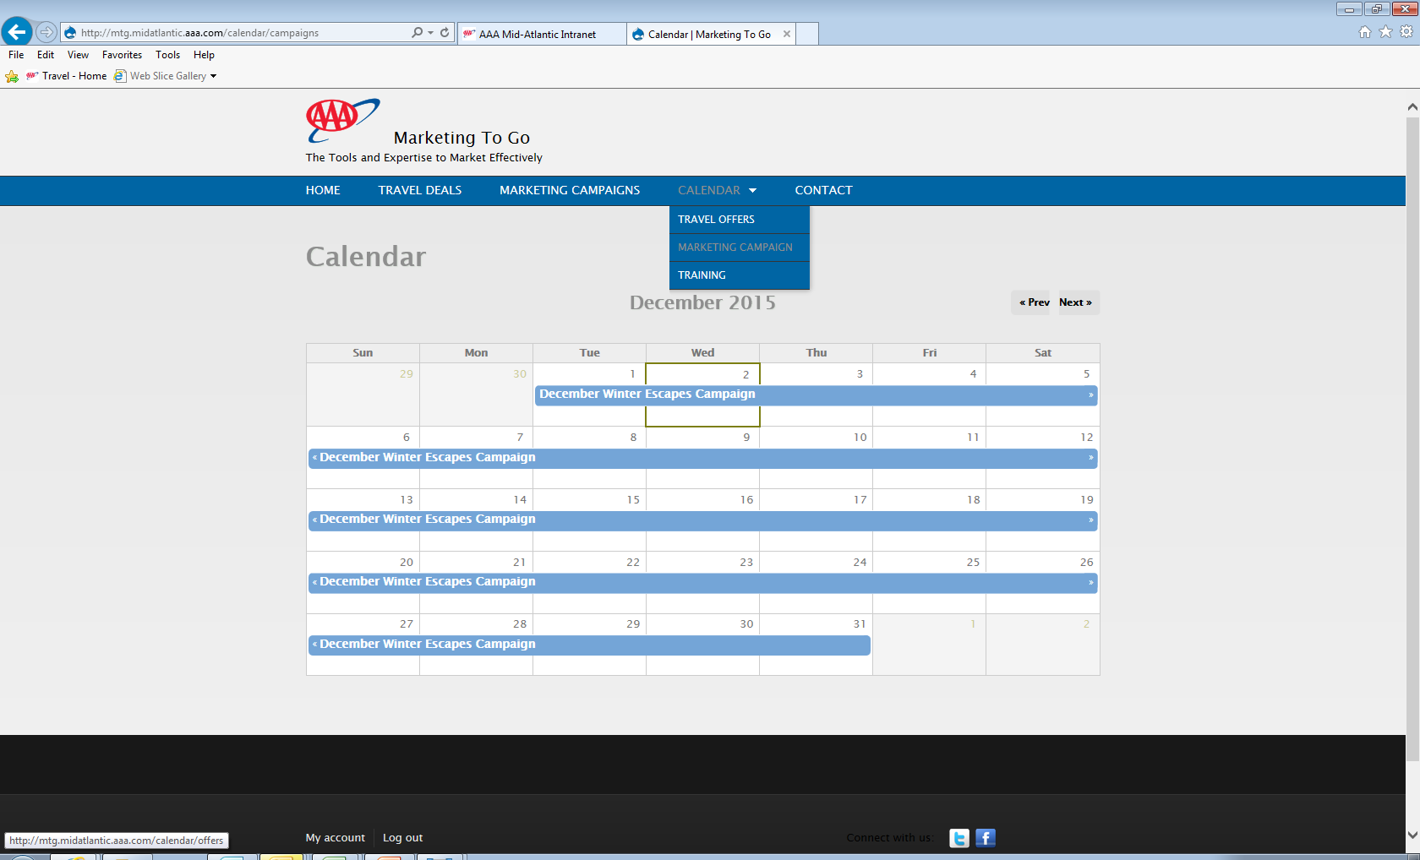

**Click on any campaign listed on today’s date to see what is in the marketplace…**