

January 2026 2-for-1 Air Partner Brief

2-for-1 Airfare Offer Overview
Companion flies free on select 2026 Guided Tours or Custom Private Driver vacations across all CIE Tours destinations (Ireland, Britain, Iceland, Italy, and Spain).

Booking Window
January 2–30, 2026

Travel Window
All 2026 through December 31 — No blackout dates.
How to Book
• Scheduled Tours — By Phone at 800-243-8687 or Online Chat
• Private Driver — By Phone at 888-467-2685 or Email privatedriver@cietours.com

Eligible Guided Tours (alphabetical order)
Tour Name | Destinations
Best of Britain | England, Scotland, Wales
Best of Ireland South | Ireland
Best of Spain | Spain
Classic Sicily | Italy (Sicily)
English Odyssey | England
Gems of Northern England | England
Gems of Southern England | England
Highlights of Britain | England, Scotland, Wales
Icelandic Explorer | Iceland
Ireland Walking & Hiking: Cork to Kerry | Ireland
Ireland Walking & Hiking: The Northern Coast | Ireland
Ireland’s Wild Atlantic Way | Ireland
Irish Classic | Ireland
Irish Legends | Ireland
Irish Odyssey | Ireland
Irish Spirit | Ireland
Irish Supreme | Ireland
Jewels of Ireland | Ireland
Northern Lights: Quest of Iceland | Iceland
Scottish Clans & Castles | Scotland
Scottish Isles & Glens | Scotland
Taste of Britain & Ireland | England, Scotland, Ireland
Taste of Iceland | Iceland
Taste of Scotland & Ireland | Scotland, Ireland
The Scots Irish Tour | Scotland, Ireland

Eligible Custom Private Driver Vacations
• Available in Ireland, Scotland, England, Iceland, Italy based on air availability
• Minimum land spend: $4,000 per person (based on two passengers traveling together)

Editable Flyers for Advisors to Share
US: https://cietours.widen.net/s/tcpxhgjp7d
Canada: https://cietours.widen.net/s/ss8gvnx2vh

Expanded Marketing Tools (including B2B flyers, social posts, and videos)
CIE Tours Travel Agent Marketing Resource Center
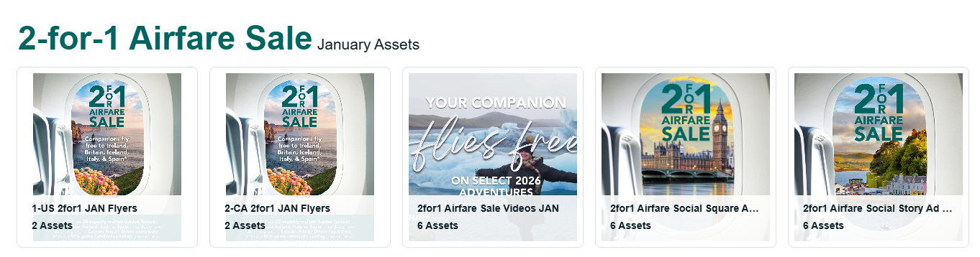

Promo Pages
US: https://www.cietours.com/offers/2-1-airfare
CA: https://www.cietours.com/en-ca/offers/2-1-airfare

Full Terms & Conditions
*2 for 1 Airfare Terms and Conditions: Call 1-800-243-8687 or contact your travel agent and mention promo code 2FOR1126 for airfare offer. When purchasing one economy class airline ticket, get a second ticket on the same flight in the same class of service including all taxes/fees, with the booking of select tours to Dublin, Shannon, Edinburgh, London, Reykjavik, Madrid, Barcelona, and Palermo from most U.S. and select Canadian gateways for bookings made 1/2/26–1/30/26 for travel between 1/2/26–12/31/26. Maximum savings for the second ticket vary based on travel date, carrier, class of service and departure airport. Seats are limited and subject to airline capacity control. Offer may not be available on desired travel dates or from desired gateways, in which case other companion airline ticket promotions and savings may be available. Offer only valid in conjunction with the following select 2026 CIE Tours itineraries: Best of Britain, Best of Ireland South, Best of Spain, Classic Sicily, English Odyssey, Gems of Northern England, Gems of Southern England, Highlights of Britain, Icelandic Explorer, Ireland Walking & Hiking: Cork to Kerry, Ireland Walking & Hiking: The Northern Coast, Ireland's Wild Atlantic Way, Irish Classic, Irish Legends, Irish Odyssey, Irish Spirit, Irish Supreme, Jewels of Ireland, Northern Lights: Quest of Iceland, Scottish Clans & Castles, Scottish Isles & Glens, Taste of Britain & Ireland, Taste of Iceland, Taste of Scotland & Ireland, The Scots Irish Tour and Custom Private Driver vacations (subject to minimum land spend of $4,000 per person based on two passengers traveling together). Airfares must be purchased through CIE Tours, are non-refundable and non-commissionable, and are subject to airline-imposed change penalties starting from $350 per ticket plus any fare differentials per passenger at re-ticketing. Airfare includes all applicable taxes and carrier-imposed charges. Full payment for airfare is due at time of booking plus a $350 per person non-refundable deposit for the land portion of the vacation within 5 days of making reservation. Additional deposit for Custom Private Driver vacations may be required depending on 3rd party requirements for specialty visits, hotels or destinations. Not all tours, flights or travel dates are eligible for offer. Companion ticket offer subject to qualifying tour criteria and travel periods listed above and cannot be applied toward any other tours, vacations or travel periods. Baggage fees may apply, see https://iflybags.com for details. Offer cannot be combined with any other CIE Tours promotions or discounts except the repeat guest incentive for verified past guests. Offer not available for Groups or self-drive options. Contact the Groups Department at 800-223-6508 for alternative Groups offer. Offer valid on new bookings only, may be withdrawn at any time, and is subject to availability. Other conditions and restrictions may apply. Advertised tour prices are per person, land only, based on double occupancy and vary by departure date. Must call to book, booking not available on cietours.com. CIE Tours standard Terms & Conditions apply. CST#202 1285-50.
** Complimentary in destination group airport transfers apply when booking air with CIE Tours and traveling on the official start and end dates of your tour. Guests arriving outside these dates or on flights that do not align with scheduled group transfer times may require private transfers at an additional cost.

