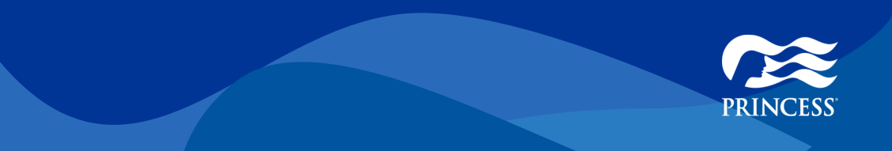
July LBEBS Boost #1: Up to $300 Instant Savings
Extended!
Memo
Offer Dates | 7/25/2025 - 7/31/2025
Offer Details | For a limited Time: Up to $300 Instant Savings!  + Up to 40% off  + Free 3rd & 4th Guests  - Up to $300 Instant Savings - Guests with single occupancy will receive single, per guest savings amount.  - Free 3rd & 4th Guests - will apply to a select number of voyages.  - Available on published voyages that have not yet reached final payment.
Product Included | Available on select 2025 – 2027 sailings on over 300 voyages.
Campaign Codes | DE5LT840 / A
Promo Codes | Base LTO: NES | NEP | NNE  Additional Up to $300 Instant Savings Promo Code: 2B6
Eligible Audience | Available to legal residents of North America.
Available to Book Through | Guests may book their cruise through their preferred Travel Advisor, Cruise Vacation Planner, 1-800-PRINCESS or princess.com.
COMBINABILITY:
Combinable | Offer
N** | Public Offer:  - Standard Fare  - Princess Plus  - Princess Premier
PA1 | Captain’s Circle Launch Savings
G** | Standard & Celebration Group Amenities and Count Goes Toward TC
CN* | Cruise Sales
DM* | Military Benefits
DS* | Shareholder Benefits
1** | Agency Offers
VA* / VB* | AMEX Gold/Platinum Cardholder
Not Combinable | Offer
RG* | Last Minute Deals
2B* | Trade Focused Public and other Recipient Only Offers
L** | Standard Group Rates
R** | Geo-Targeted / Resident Special
U** | Past Guest / Prospect; Recipient Only
XXC | Celebration Group Rate
EN* | Casino Sail & Play
E** | Casino Comp Cabins
FE* / FP* | Net Rates
FA* | Closed User Groups
XX* | Special Contract Rates
YT* | Travel Advisor Rates
YI* | Interline Rates
5** | Casino % Discount
OB* / ZH* | Special Onboard Sales Offers
Ongoing Programs | Offer | Audience | Dates
Better Than Best Price Guarantee | 120% price match when lower fare is found on Princess cruise prior to final payment | Public | 12/15/2025

