As a HX preferred travel partner we are delighted to provide you with advanced campaign information to help you plan for the 2025 Black Friday Campaign. In the spirit of a true partnership, we ask that this information remains highly confidential within your business and not shared externally until the embargo dates listed in the pack. The information in the pack is subject to change before going live without prior notice so please ensure any marketing is sent for approval to HX.

Contents

- Campaign overview
1.1 Campaign dates
2. Offer mechanics and lead pricing
2.1 Offer 1 mechanics and lead pricing
2.2 Offer 2 mechanics and lead pricing
2.2 All-inclusive messaging
3. Pricing
3.1 See attached pricing file for all pricing
4. T&Cs
5. HX tools

- Campaign overview

  - - Dates
- The campaign will be live from 3rd November to 3rd December 2025

- Offers and promotions

2.1 - Offer details

- To celebrate Black Friday we are offering Up to 35% discount on our Black Friday deals.
- Discounts on selected HX departures from 14 January 2026 to 19 March 2027 (inclusive)
- HERO Destinations: Antarctica, Greenland, Svalbard, Alaska, Northwest Passage, Galapagos, Iceland, Arctic Canada, Norway, South America and Europe

Destination | Ship | Sailing Date | Cruise Nights | Tour Name | GBP
Alaska | MS Roald Amundsen | 6/13/2026 | 9 | Alaska's Inside Passage: Fjords of The Great Land | $4,053
Canda | MS Roald Amundsen | 9/21/2026 | 16 | Greenland, Labrador and Newfoundland - Encounters at the Edge | $10,077
Greenland | MS Fridtjof Nansen | 6/2/2026 | 12 | Discovering Greenland – From Reykjavik to Nuuk | $8,045
Iceland | MS Fridtjof Nansen | 5/19/2026 | 7 | Elemental Iceland - Circular Saga from Reykjavik | $4,664
Svalbard | MS Spitsbergen | 6/9/2026 | 7 | Svalbard in Spring - The Return of the Sun | $6,610
Antartica | MS Fridtjof Nansen | 3/20/2026 | 17 | Antarctica & Falklands Expedition (Northbound) | $9,921
Norway | MS Spitsbergen | 3/21/2026 | 7 | Ultimate Norway – Arctic Expedition under the Northern Lights | $3,987
Galapagos | MS Santa Cruz II | 1/16/2026 | 6 | Galápagos Islands Expedition Cruise – In Darwin’s Footsteps | $6,009

See price finder for all pricing

2.2 All Inclusive

An HX trip includes everything from daily excursions and activities to our onboard Science Center, meals, gratuities drinks and more. All designed to give your customers the expedition experience of a lifetime. 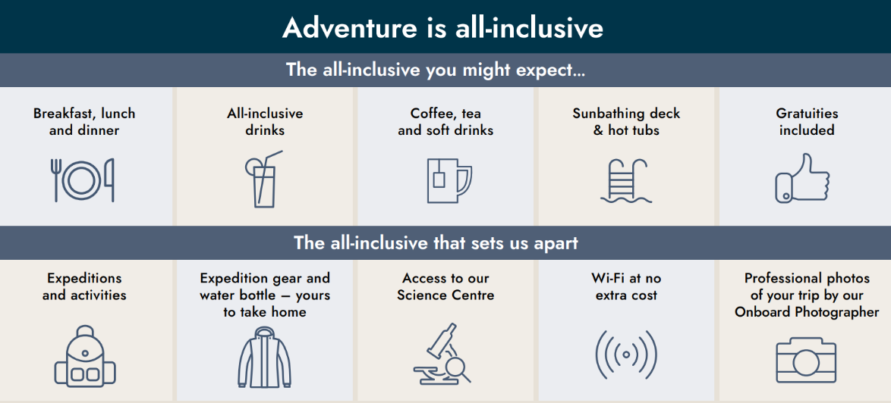

See full T&Cs here: https://www.travelhx.com/en-us/stories/adventure-is-all-inclusive/

- Pricing
3.1 - Pricing file
- See attached file for detailed pricing.
- Please contact your sales team for all other pricing

- T&Cs

4.1 Short T&Cs

Save up to 35% applies to bookings made from 03 November 2025 to 03 December 2025 (inclusive)
for selected HX departures from 14 January 2026 to 19 March 2027 (inclusive). Bookings outside of these periods do not qualify. Offer is subject to availability and may be withdrawn at any time without prior notice. Single supplements may apply and applies to all offer occupancies. Combinable with the HX Explorers loyalty program.

5. HX Tools
5.1 - Agent Portal

Our agent portal is our one stop shop to find all the Black Friday product.
You can also access online training, find marketing materials and book! Plus, so much more.
Hurtigruten Expeditions Agent Portal

5.2 Contact our GX call center team
If you have any questions or would like support in making a booking then please contact our Expedition Travel Specialists in the GX team- +1 (866) 312-6791 (US & CA).

